DATE September 13, 2022 RELEASE NUMBER 50/22

Top 10 Tips from Outrigger Maldives Maafushivaru Resort
on Viewing Manta Rays
It’s World Manta Day on 17 September
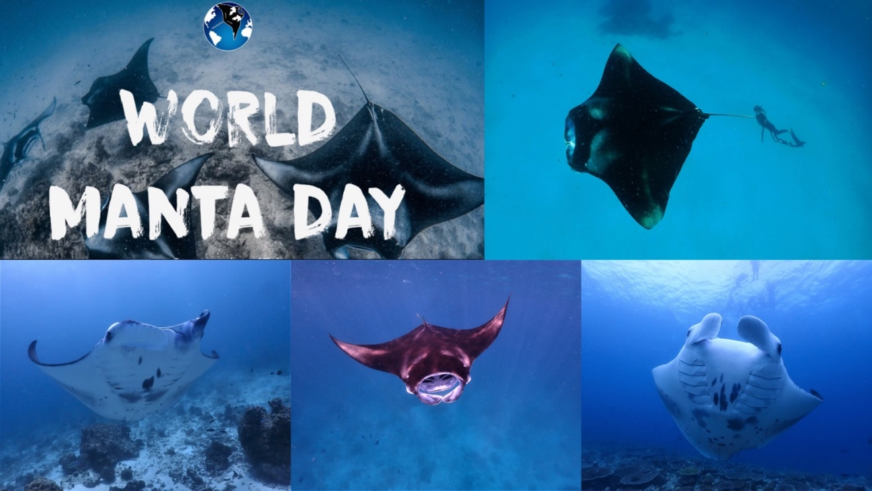
Reef manta rays feed on microscopic plankton, grow up to four meters from wingtip to wingtip,
and can weigh up to 1500lbs [Image top left courtesy of WorldMantaDay.com; download images HERE]

MALE, MALDIVES – Ahead of World Manta Day on September 17, Lynn Jula Kessler, the marine biologist at Outrigger Maldives Maafushivaru Resort offers the following advice on viewing the gentle giants.

1. When to go?
The manta rays’ migration pattern is dominated by the two monsoon seasons in the Maldives. From roughly December to May we find the mantas more frequently on the Western atolls. From June to November we mainly focus our search on the eastern sites. In South Ari Atoll around Outrigger Maldives Maafushivaru Resort, we are extremely lucky to record year-round sightings of manta rays, as the animals don’t leave the atoll when the monsoon is changing (due to the geographical size of the atoll). Most manta sightings have been recorded between October and March.

2. Videos and books to enjoy in preparation
The Manta Trust has published a fantastic Guide to Manta and Devil Rays, which gives a great overview of all the manta species known to science, with helpful identification keys. For a more aesthetic book, I recommend the Secret Life of Manta Rays, co-authored by Dr. Guy Stevens, the founder of Manta Trust. This book has stunning photographs and interesting insights to the conservation efforts, plus it’s a beautiful coffee table book. As one of the biggest threats to manta ray populations around the world is overfishing, I can recommend Seaspiracy on Netflix to familiarize yourself with overexploitation of the seas.

Top 10 Tips from Outrigger Maldives Maafushivaru Resort
on Viewing Manta Rays
Pg. 2 of 3

3. Choose a resort with a dedicated marine biologist or conservationist
Many resorts in the Maldives have a resident marine biologist or conservationist on site. With a bit of research, or by contacting the resort directly, you can find out how well the marine biologist is included in the resort’s ocean activities — and what other types of sustainability efforts are being pursued by the resort. At Outrigger we have our global nature conservation program called OZONE — Outrigger’s ZONE.

4. Do a trial snorkel or scuba dive first
This is important, especially if you are not a strong swimmer or have little experience snorkeling in the ocean. Try snorkeling in a safe environment first. This way you can familiarize yourself with the equipment, practice being in open water, and increase the chance of a more enjoyable manta dive or snorkel excursion.

5. Be ready!
If you join a group trip make sure you listen to your guide’s instructions and are ready to get into the water at any moment!

6. Don’t get too close
Manta rays are very curious by nature. We try to stay at about a 10-14-foot radius. But due to mantas’ inquisitive nature they almost always break this distance themselves. The best advice I can give when it comes to manta ray encounters is to stay as calm as possible. The chances of the manta ray turning around and checking you out from up close are much higher when you remain calm at the surface rather than splashing around and chasing after it. However, don’t try to touch a manta ray. This will most likely end the encounter as mantas are not tactile animals and get scared when being touched.

7. Photography tip
Many times I have seen guests more focused on their camera settings than on the mantas themselves. If you are not familiar with your camera settings or you don’t want the extra pressure of having to take pictures as well as keeping up with mantas, leave the camera behind. However, action cameras such as GoPros are usually a very easy solution and make great footage and can be rented at the dive center. If you join a trip with me, you can be certain that I always carry a camera. I am more than happy to share my pictures.

8. Instagram channels to keep an eye on
If you are interested in manta rays, I recommend the channels from Manta Trust (@mantatrust) and the Maldivian Manta Ray Project (@maldianmantaproject). On the OZONE Maafushivaru (@ozone_maafushivaru) channel, I share information and insights on manta rays as well as other marine projects at Outrigger Maldives Maafushivaru Resort.

9. What is Outrigger Maldives Maafushivaru Resort doing on Manta Ray Day?
For World Manta Day we have a scheduled manta ray excursion for our guests. I will be joining as well, providing participants with insights into the manta rays’ life and briefing everyone on proper in-water behavior. All data collected during this trip will be submitted to the Maldivian Manta Ray Project and the Manta Trust, which is the world’s leading organization on manta ray research and conservation.

10. Learn more about mantas and the responsible resort approach
Find out more about World Manta Day at WorldMantaDay.com. It’s a great resource with information links, a list of challenges facing mantas, upcoming events, and how to get involved. The Outrigger OZONE page also gives useful insights on coral protection and propagation initiatives, reducing waste, guest education and the best eco-activities for responsible travelers.

Top 10 Tips from Outrigger Maldives Maafushivaru Resort
on Viewing Manta Rays
Pg. 3 of 3

Related links:
Outrigger Kona Resort & Spa in Hawaii to Host World Manta Day Festival, 17 Sept
Outrigger Maldives Maafushivaru Resort Playing an Important Role in Manta Ray, Whale Shark & Turtle Conservation
About Outrigger’s Nature Conservation Initiative - OZONE
About World Manta Day

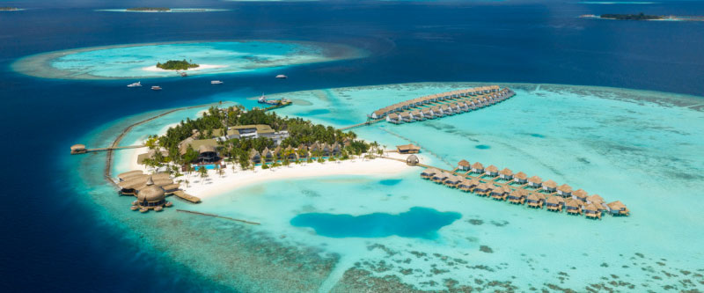
Outrigger Maldives Maafushivaru Resort: an ideal base for manta ray discoveries in the South Ari Atoll.

# # #
ABOUT OUTRIGGER MALDIVES MAAFUSHIVARU RESORT
Discover a unique Island Experience in the Indian Ocean offering small island charm with contemporary architecture and bespoke finishing touches. In the pristine South Ari Atoll, the 5-star Outrigger Maldives Maafushivaru Resort is a 25-minute seaplane journey from Male. It offers 81 villas in five distinct styles plus four restaurants, bars and cafes, a spa, a library lounge, boutique, airport lounge and transfers. The resort features a fully equipped PADI and SSI dive center, island excursions, movie and documentary nights and vow renewals for couples. It has its own in-house marine biologist who leads marine discovery trips, a coral regeneration project, and gives marine life presentations twice a week as part of the Outrigger OZONE global nature conservation initiative. More at Outrigger.com.

ABOUT OUTRIGGER HOSPITALITY GROUP
For nearly 75 years, Outrigger Hotels and Resorts has charted a journey of discovery – expanding from Hawaii to premier resort destinations including Fiji, Mauritius, Thailand and The Maldives. The privately held hospitality company invites guests to ‘Escape Ordinary’ with authentic Signature Experiences and the Outrigger DISCOVERY loyalty program. Outrigger’s multi-branded portfolio includes Outrigger® Resorts, OHANA Hotels by Outrigger®, Hawaii Vacation Condos by Outrigger®, Kapalua Villas Maui, and its newest addition, Honua Kai Resort & Spa Maui while also managing select properties from top international hotel brands including Embassy Suites® by Hilton, Best Western® and Hilton Grand Vacations®. Find out more at Outrigger.com or visit @OutriggerResorts on Facebook, Instagram and Twitter.

OUTRIGGER MEDIA CONTACTS, ASIA & EUROPE
Ken Scott | ScottAsia Communications | Mobile: (+44) 7949 077959 | Email: kens@scottasia.net
Anchalee Sriwongsa | ScottAsia Communications | Mobile: (+66) 91 806 0484 | Email: ann@scottasia.net

NORTH AMERICA
Monica Salter | VP Global Communications & Social Responsibility
Outrigger Hospitality Group | Tel: (+1) 808-921-6839 | Email: monica.salter@outrigger.com

